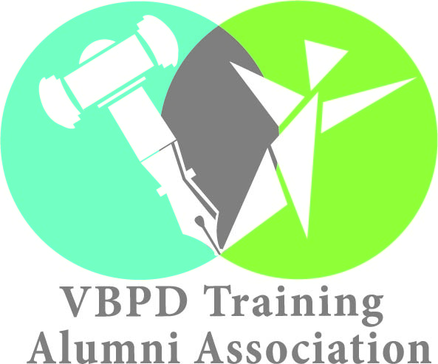

**NORTHERN VIRGNIA (NoVA) Co-Chairs**

**Name Email**

Selonia Miles [seloniamiles@gmail.com](mailto:seloniamiles@gmail.com)

Danielle Dague [ddague78@icloud.com](mailto:ddague78@icloud.com)